**LAB ASSIGNMENT 4**

1. Image Quantization (Uniform):

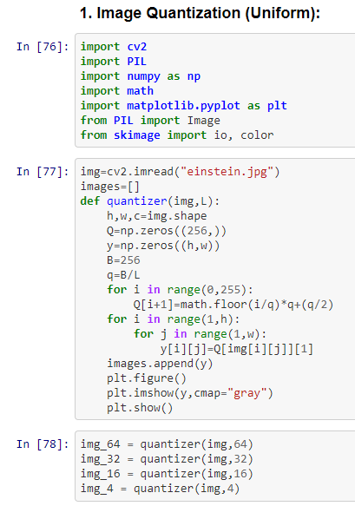

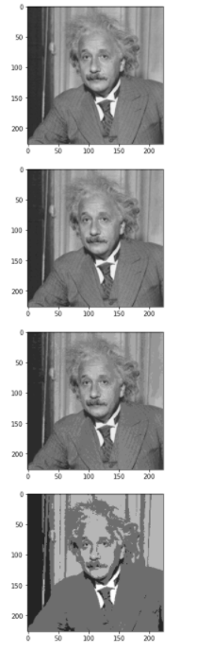

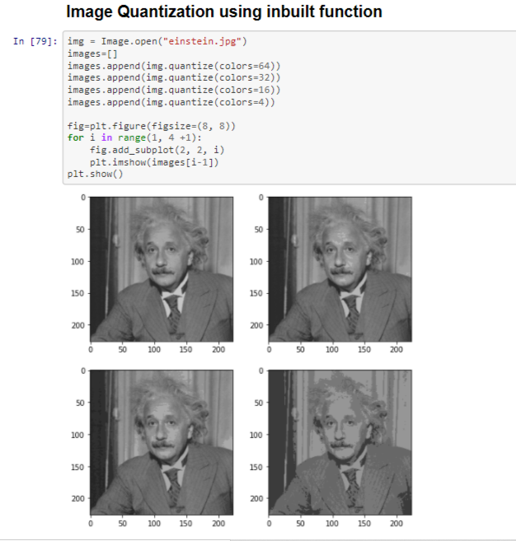

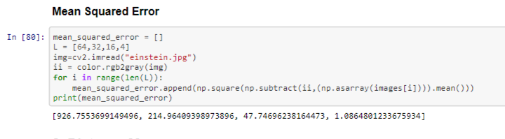

**Q2 - Distance Measures:**

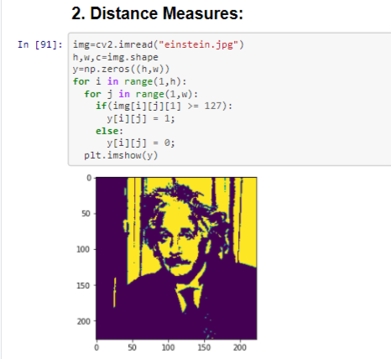

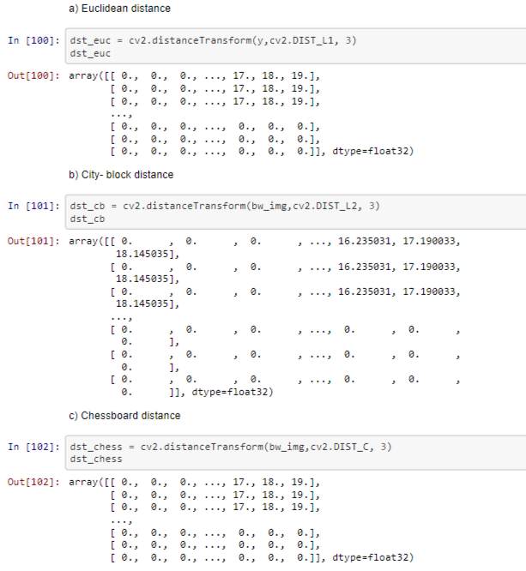

**Q3 –** Write a program to implement spatial domain averaging filter and to observe its blurring effect on the image without using inbuilt functions. Study the effect of applying mean filters of 3x3 5x5, 7x7 on images and compare results.

